Thursday, April 23, 2015

9 am - Jon Schipp/Wayland Morgan

Presentation: ISLET (Isolated, Scalable, & Lightweight Environment for Training)

Abstract: ISLET (Isolated, Scalable, & Lightweight Environment for Training)
is a system that streamlines Linux based software training for IT events. It minimizes the participation barrier to that of an SSH client. It uses Linux containers to provide students with isolated environments from which they can perform work. ISLET is used at the University of Illinois at Urbana-Champaign to teach digital forensics tools and by the Bro Project to teach Bro, among other use cases. This talk will discuss ISLET, the problems it solves, a technical overview of Linux containers, and includes a live demonstration of standing up a brand new ISLET system in under 10 minutes.

Bio: Jon Schipp is on the security operations team at the NCSA, and an IT consultant. He is the author of ISLET and a contributor to many Free and Open Source Projects including The Netsniff-NG Toolkit, SecurityOnion, and the Bro Project. Founder of the Open Network Security Monitoring Group (OpenNSM), a weekly research and user DFIR/NSM group without borders, along with multiple LUG's, and the Southern Indiana Computer Klub (SICKbits). Jon has had the pleasure of speaking at many conferences including Derbycon, Hack3rCon, AIDE, BroCon, MOSSCon, and more. He enjoys death metal, intellectual history, and recreational volleyball. More info at http://jonschipp.com
Wayland Morgan is an IT Security Analyst at the University of Illinois at Urbana-Champaign where he is the team lead for Digital Forensics, Incident Response, and eDiscovery at the University's Office of Privacy and Information Assurance. Wayland began his Information Security career as a vulnerability analyst for a Fortune 200 energy company and since has led several high profile intrusion cases in a heterogeneous R1 research environment. In addition to a bachelors degree in Management Information Systems, Wayland holds several industry recognized certifications such as GCIH, GCFE, GCFA, CISSP, CISA, and ITIL.

Thursday, April 23, 2015

10 am - Kim Detardo-Bora/Bill Gardner/Amanda Richards

Kimberly A. DeTardo-Bora is a Professor of Criminal Justice and Criminology at Marshall University where she serves as both undergraduate and graduate program director. She obtained her Ph.D. in Criminology from Indiana University of Pennsylvania in 2003. Her most recent endeavor has been exploring the world of “hacktivists.” In Fall 2014, she presented a paper titled, “Peering into Hacktivism: The Search for a Criminological Lens” with co-authors Bill Gardner and Amanda Richards. Besides a book titled, West Virginia’s Criminal Justice Systempublished with co-authors Dhruba Bora and Samuel Dameron, Dr. DeTardo-Bora’s research has been published in scholarly venues such as Action Research, Corrections Compendium, Security Journal, and Women and Criminal Justice.

Bill Gardner is an Assistant Professor at Marshall University, where he teaches in the Digital Forensic and Information Assurance Program. He is also President and Principal Security Consultant at BlackRock Consulting, and the Information Security Chair at the Appalachian Institute of Digital Evidence. Prior to joining the faculty at Marshall, Bill co-founded the 304Geek and Hack3rCon. Bill is the coauthor of "Building an Information Security Awareness Program: Defending Against Social Engineering and Technical Threats" with Valerie Thomas, which was published in August.

Amanda Richards is a graduate student in the Criminal Justice and Criminology Program at Marshall University.

Thursday, April 23, 2015

11 am - Adrian Crenshaw

Presentation: TBA
Abstract: TBA

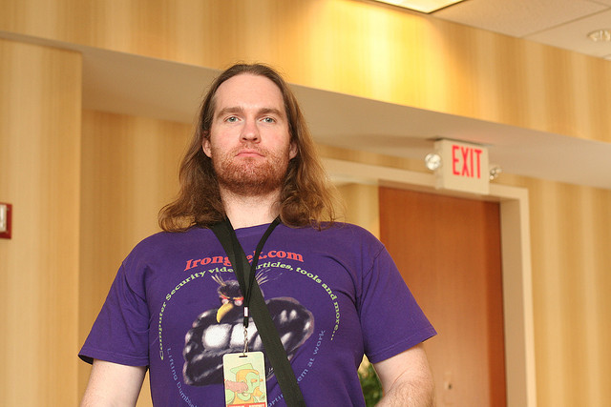

Adrian’s BIO: Adrian Crenshaw has worked in the IT security industry for the last twelve years. He runs the information security website Irongeek.com, which specializes in videos and articles that illustrate how to use various pen-testing and security tools. Adrian is one of the founders of DerbyCon, a large-scale hacker conference located in Louisville Kentucky. Adrian frequently presents at a number of large and small INFOSEC conferences, and contributes to a number of open-source projects.

You can follow Adrian on Twitter: @irongeek_adc

Noon – Lunch

Thursday, April 23, 2015

1 pm – Tess Schrodinger

Presentation: TBA
Abstract: TBA

Bio: Tess Schrodinger has over twenty years in law enforcement, investigation, forensics (bullets & blood, not 1s & 0s), and industrial security. She holds a Bachelor of Sociology, a Master of Security Management, and a graduate certificate in cybersecurity technology. One of her many current objectives is to bridge the gap between traditional security and cyber security by promoting awareness and education to the technologically ignorant who are often overwhelmed by the potential threats and how they can be targeted and to the technically gifted who are often unfamiliar with the threats, vulnerabilities, and mitigation techniques that lie outside their world of technology.

Thursday, April 23, 2015

2 pm – Aeadan Somerville/Shawn Jordan

Presentation: Introducing Network Scout: Defending the Soft Center of Your Network

Abstract: Everyone is watching the edge of their network. We have installed firewalls, IDS, IPS, and other defensive technologies at the network edge. Network-Scout moves these technologies inside your network to monitor for malicious activities that gets by traditional network perimeter defenses. Network-Scout is a distributed IDS, IPS, and Honeypot that is built on a Raspberry Pi using off-the-shelve technologies for under $150 per device.

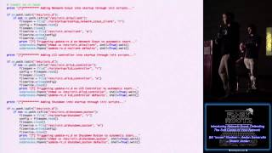

Bios: Shawn Jordan and Aedan Somerville are seniors at Marshall University. They are currently majoring in Digital Forensics and Information Assurance. Shawn Jordan runs a small home inspection company, leads a small college church group, and is conducting forensic research. Aedan Somerville works part time at a local restaurant and is president of the Marshall CCDC team.

Thursday, April 23, 2015

3 pm – 5 pm– Jeremy Druin - Mutillidae (two hour presentation)

Presentation: TBA

Abstract: TBA

Bio: Jeremy Druin GISF, GSEC, GPEN, GXPN, GWAPT, GMOB, Sec+ Email: jeremy@ellipsisinfosec.com Twitter: @webpwnized Jeremy works as a internal pen-tester, application security consultant, and defect-remediation expert for a multi-national transportation logistic company. Jeremy is also the owner of Ellipsis Information Security assisting the community with these security services. Additionally Jeremy develops the open-source Mutillidae 2.x training environment and teaches on security topics. As a Director of Education for the Kentucky ISSA chapter, Jeremy presents on web application pen-testing and remediation along with operating the "webpwnized" YouTube video channel. Jeremy has a Bachelors in Computer Science from Indiana University and is a GIAC-certified Web Application, Mobile and Network Pen-Tester.

Friday, April 24, 2015

9 am – Tom Moore

Presentation: TBA

Abstract: TBA

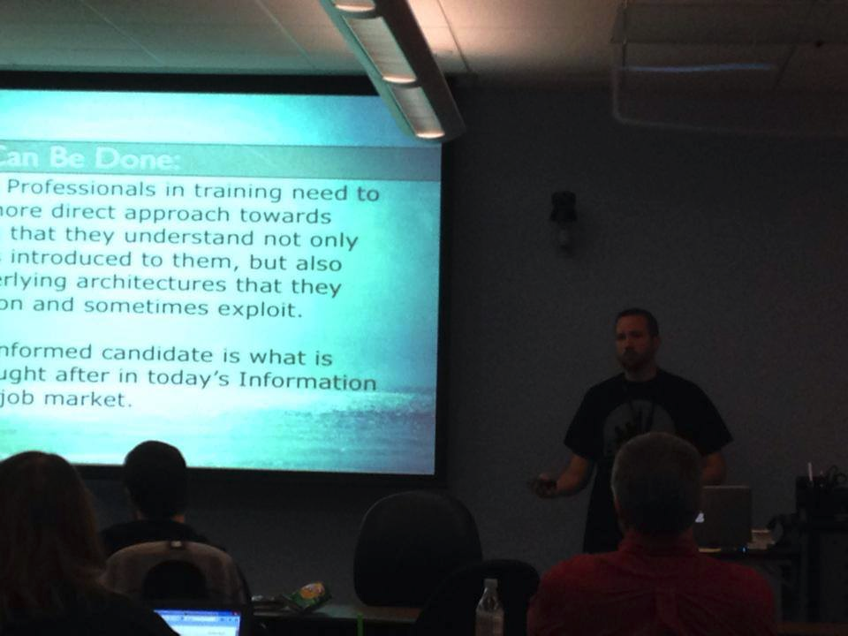

Bio: (c0ncealed) Tom Moore is a Penetration Tester and former Red Team member for a Fortune 50 organization. He has an extensive background in network administration and web development. He is a graduate of Marshall University, member of 304Geeks, and the Security Awareness Training Framework project. He is an unremitting g33k, husband, father, and christian. He enjoys his 2nd amendment, outdoor primitive recreation, photography, gaming, lock picking, and inserting random single quotes where they don’t belong.”

Twiter: @c0ncealed’s

Friday, April 24, 2015

10 am - Elliott Cutright

Presentation: TBA

Abstract: TBA

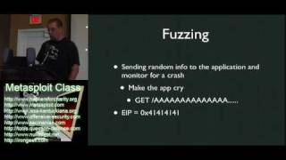

Bio: TBD

Friday, April 24, 2015

11 am – Brian Martin

Presentation: TBA

Abstract: TBA

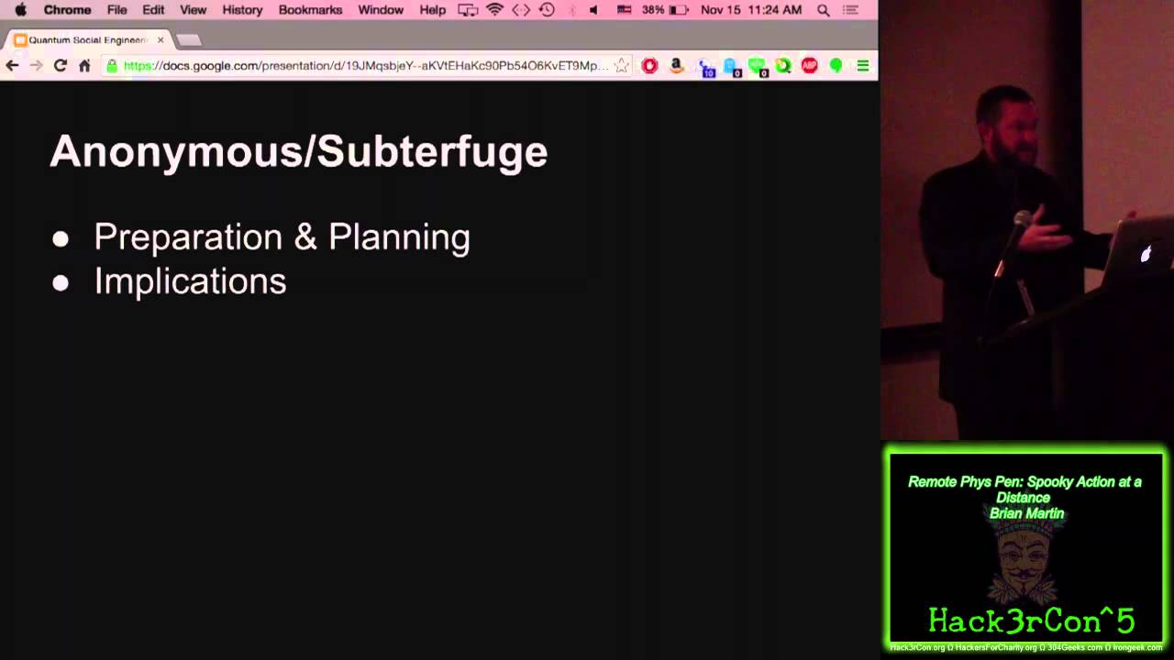

Bio: TBD

Noon – Lunch

Friday, April 24, 2015

1 pm – Frank Hackett

Presentation: TBA

Abstract: TBA

Bio: TBD

Friday, April 24, 2015

2 pm – Dave Kennedy (Keynote)

Presentation: TBA

Abstract: TBA

Bio: David Kennedy is the founder and CEO of TrustedSec and Co-Founder and CTO of Binary Defense Systems (BDS). Kennedy is a co-author of the book “Metasploit: The Penetration Testers Guide,” the creator of the Social-Engineer Toolkit (SET), and the creator of Artillery. Kennedy has presented on a number of occasions at Black Hat, Defcon, ShmooCon, BSIDES, Infosec World, Notacon, AIDE, ISACA, ISSA, Infragard, Infosec Summit, and a number of other security-related conferences. Kennedy has been interviewed by several news organizations including CNN, Fox News, and BBC World News. Kennedy is one of the co-authors of the Penetration Testing Execution Standard (PTES); a framework designed to fix the penetration testing industry. Kennedy is the co-founder of DerbyCon, a large-scale conference in Louisville Kentucky. Prior to the private sector, Kennedy worked for the three letter agencies and deployed to Iraq twice for intelligence related missions.

Twitter: @HackingDave

Friday, April 24, 2015

3 pm – Jayson Street (Keynote)

Presentation: TBA

Abstract: TBA

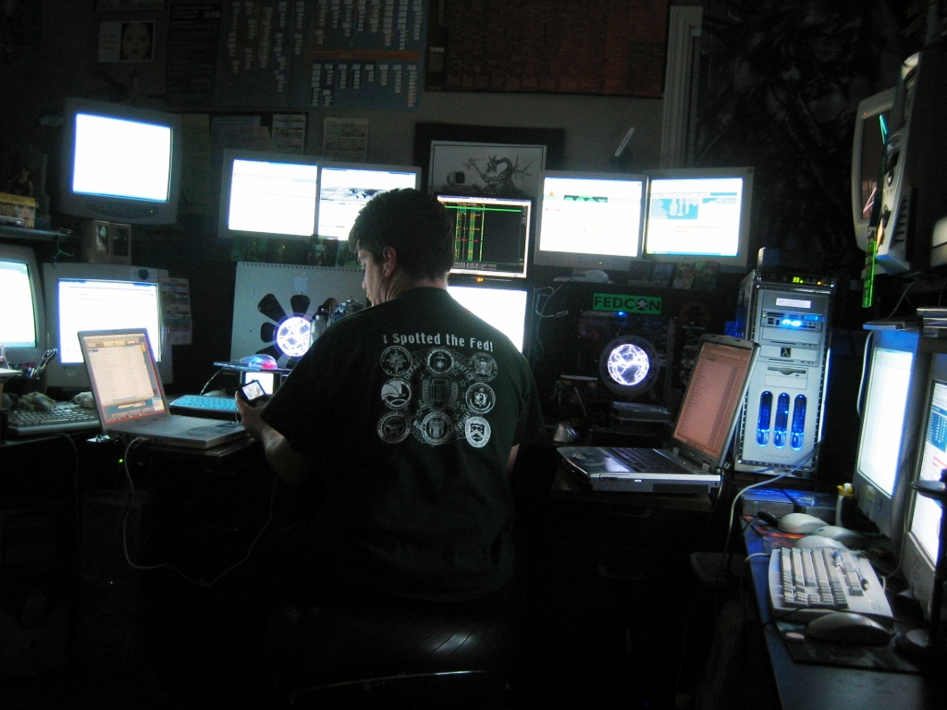

Bio: Jayson E. Street is an author of “Dissecting the hack: The F0rb1dd3n Network” from Syngress. Also creator of http://dissectingthehack.com He has also spoken at DEFCON, DerbyCon, UCON and at several other ‘CONs and colleges on a variety of Information Security subjects. His life story can be found on Google under “Jayson E. Street” *He is a highly carbonated speaker who has partaken of Pizza from Beijing to Brazil.

Twitter: @jaysonsteet

